Lecture 3 Lab Session
  - RV32I Instructions and Programs
Student handout | 120 minutes | Individual report with paired exploration
Name: Anas Bin Jaman(阿努) Student ID: 3012020431150 Date: 11/11/2026
In this lab, you will make a small processor program explainable. Predict what each instruction changes, execute it in a simulator, and use register and memory evidence to explain the result. The main experiment uses the lecture array [3, -1, 4].

Learning outcomes
- Trace arithmetic instructions using current register values and the program counter.
- Distinguish an address from the value stored there; explain word and byte transfers.
- Verify an array loop for empty and nonempty inputs, including its stopping condition.
- Diagnose the first incorrect state and package the loop as a simple function.

Session schedule
Minutes | Activity | Evidence to keep
0–10 | Setup and prediction routine | RV32 setting and actual addresses
10–25 | A Registers and instruction effects | Completed state table
25–45 | B Memory and byte transfers | Byte map and load results
45–80 | C Array sum and instruction count | Boundary tests and loop snapshots
80–100 | D Debug three mutations | First failure and repair
100–115 | E Turn the loop into a function | Working code and preserved state
115–120 | Exit ticket and submission | Short explanations

Before starting
Review lecture slides 7–18, 19–33 and 34–65. For byte transfers and functions, use slides 71–79 and 83–90. You should know hexadecimal notation, two’s complement and basic while loops. All arrays in this lab contain 32-bit integers.

Setup and working rules
- Download RARS 1.6 from the official link on the final page. Start the jar with Java, for example: java -jar rars1_6.jar. The instructor should prepare this before class.
- Use the default RV32 mode and Default memory configuration. Ensure RV64 mode is off. Assemble only the file you are working on; turn off any option that assembles every file in its directory.
- Open 01_register_trace.s, assemble it, and locate the text, register and data displays. Check the assembled Basic instruction column when the source uses la or li.
- Set a breakpoint on the instruction next to the named label. A breakpoint stops before that instruction. Use single step to execute one real machine instruction and observe the new state.
- After changing n, data or code, save and reassemble. Start each independent test from its initial state. A reset of only the PC does not restore overwritten memory.

Keep the teaching model consistent
Use 32-bit registers, byte-addressed little-endian memory and ordinary 4-byte RV32I instructions. A word occupies four bytes. Observe the assembled addresses; the lecture’s data base 0x1000 and zero-based instruction listing are illustrative, not addresses to type into RARS.
Let B mean the actual array base and S mean the actual address of trace_start. Write both once and express later addresses as B+offset or S+offset. Offsets are in bytes unless explicitly stated otherwise.
Numbered name | ABI alias | Use in this lab
x0 | zero | Always reads zero
x5, x6, x7 | t0, t1, t2 | Sum, index, pointer in Task C
x8 | s0 | Temporary only in standalone Task C
x10, x11 | a0, a1 | Base and length inputs
x28 | t3 | Temporary in the Task E function
x1, x2 | ra, sp | Return address and stack pointer

The assembler conveniences la and li may expand into multiple instructions. Task C excludes its input wrapper from the count. The final a7=10 / ecall sequence exits RARS; it is outside the experiment’s counted region and is not a portable operating-system interface.
For every task, write a prediction before running. If the observation differs, locate the first differing instruction before changing the program.

Task A Register trace
Time 15 minutes | File 01_register_trace.s | Lecture slides 7–18
The setup establishes x5=9, x6=4 and x7=0. Stop at trace_start. The following four instructions form the experiment.
sub x7, x5, x6
addi x5, x7, -1
add x6, x5, x7
add x0, x5, x6

- Fill the prediction table without running the code. Each row describes the state after that instruction.
- Single-step the four instructions and compare the observed values. Stop at lab_done before its nop.
- Record the PC immediately before and after the first sub. Explain the change in bytes.
- Find the machine-code word for sub in the assembled display. Explain why source text and machine encoding are two representations of the same operation.
After instruction | x5 | x6 | x7 | x0
Initial state | 9 | 4 | 0 | 0
sub x7, x5, x6 | 9 | 4 | 5 | 0
addi x5, x7, -1 | 4 | 4 | 5 | 0
add x6, x5, x7 | 4 | 9 | 5 | 0
add x0, x5, x6 | 4 | 9 | 5 | 0

PC before sub: 0x0040000C; PC after sub: 0x00400010, with the default textual base of 0x00400000, and the three preceding addi instructions of four bytes each. The value of PC increments by four bytes for the regular 32-bit instruction. Machine code word for sub x7,x5,x6: 0x406283B3 (normal RV32I coding).
The assembly code is human readable version while the machine code word is the actual representation of the opcode and register values.
A1 Why does the third instruction use the new x5 value?
This is because in Instruction 3, the value of x5 that was updated from 9 to 4 in Instruction 2 due to its addi operation, is read.
A2 The last addition calculates a value. Why does x0 still contain zero?
The value stored in x0 is fixed at zero. The instruction add computes 4 + 9 = 13 but writes the value to x0, making the output zero in subsequent loads from x0.
Sources with no changes in their value: Instruction sub leaves x5 and x6 as is, addi leaves x7 as is, and add leaves x5 and x7 as is.
Checkpoint: show your state table to your partner. Identify a source register that is unchanged by each of the first three instructions.
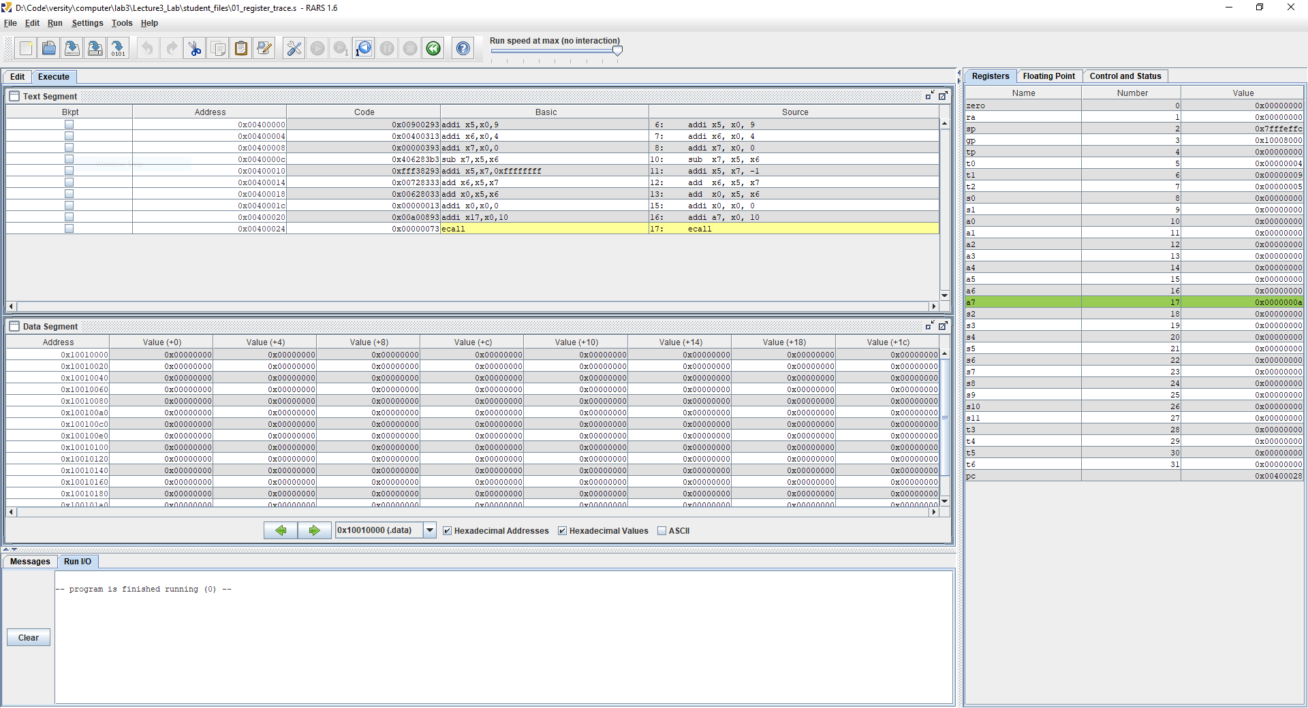
Figure A: RARS simulator execution for 01_register_trace.s showing final register values (t0/x5=4, t1/x6=9, t2/x7=5, x0=0).

Task B Memory and byte transfers
Time 20 minutes | File 02_memory_bytes.s | Lecture slides 19–29 and 71–79
This is a fresh memory experiment. Let M be the assembled address of sample. A word store first writes 0x12345678; a byte store then overwrites only the byte at M+1.
la t0, sample
li t1, 0x12345678
sw t1, 0(t0)
word_stored:
addi t2, x0, -17
sb t2, 1(t0)
bytes_changed:
lw t3, 0(t0)
lb t4, 1(t0)
lbu t5, 1(t0)

- Predict the four bytes after sw. Run to word_stored and inspect memory.
- Predict which byte sb changes. Run to bytes_changed. Record the bytes in increasing address order, then reconstruct the new 32-bit word.
- Predict t3, t4 and t5; run to lab_done and compare. Show all three as eight-digit hexadecimal values. Also give signed decimal t4 and unsigned decimal t5.
Checkpoint | M | M+1 | M+2 | M+3
After sw | 78 | 56 | 34 | 12
After sb | 78 | EF | 34 | 12

Actual M=0x10010000, t3=0x1234EF78, t4=0xFFFFFFEF, t5=0x000000EF. t4 when signed decimal is -17; t5 when unsigned decimal is 239.
B1 Why do lb and lbu read the same byte but produce different 32-bit values?
The value returned by lb is sign-extended to 32 bits since the value 0xEF has its sign bit set and hence returns a value of 0xFFFFFFEF. The value returned by lbu is zero-extended to 0x000000EF.
B2 Does sw or sb change t0 or t1? How many bytes does each store write?
The stores do not modify t0 or t1; they just use t0 for addressing and t1/t2 for the data storage. sw writes four bytes; sb writes one byte. For the default setup M = 0x10010000; verify the actual label from the sample in the assembled output.
If the data panel shows whole words, use little-endian decomposition to fill the byte table. Do not reverse the displayed word value itself.
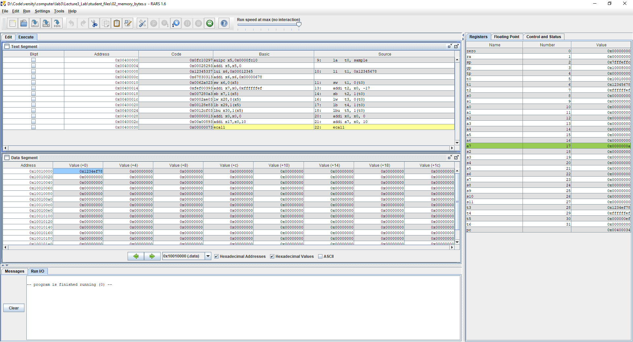
Figure B: Memory and byte transfers in 02_memory_bytes.s at sample address M=0x10010000 showing word 0x1234EF78 and loads t3, t4, t5.

Task C Trace the lecture array program
Time 35 minutes across this page and the next | File 03_array_sum.s
The wrapper loads the actual array base into x10, sets the selected length in x11, and clears x8 to zero. These are input preparation. Begin counting at trace_start and stop when the PC reaches end, before executing its nop.
trace_start:
addi x5, x0, 0 # running sum
addi x6, x0, 0 # processed element count
addi x7, x10, 0 # current pointer
loop:
beq x6, x11, end
lw x8, 0(x7)
add x5, x5, x8
addi x7, x7, 4
addi x6, x6, 1
jal x0, loop
end:
addi x0, x0, 0 # stop BEFORE this instruction

Label or instruction | Address relative to S | Purpose
trace_start | S+0x00 | Initialize the sum
loop / beq | S+0x0C | Test before memory access
lw | S+0x10 | Read one word
jal x0, loop | S+0x20 | Return to the condition
end / nop | S+0x24 | Stopping point, not counted

- Write B and S from the assembled program. Predict the n=3 run before stepping.
- Set breakpoints at trace_start, loop and end. Capture each state immediately BEFORE loop’s beq executes, including the final visit that exits.
- At each checkpoint, record x5, x6, x7 and x8. To continue from a loop breakpoint, single-step the beq and then run to the next breakpoint.
- For each load, record the effective address and the value read. After a pointer update, inspect x8 again: did changing the address also load the next value?
This is a standalone trace. Its use of x8 is copied from the lecture. In Task E, you must observe the function calling convention because x8 is also the callee-saved register s0.

Task C Boundary cases and counting
For n=3, fill these snapshots immediately before beq. B is the actual array base. The wrapper initializes x8 to zero so an empty run has an explicit unchanged sentinel.
Elements processed | x5 sum | x6 index | x7 pointer | x8 last load
0 | 0 | 0 | B | 0 (sentinel)
1 | 3 | 1 | B+4 | 3
2 | 2 | 2 | B+8 | -1 (0xFFFFFFFF)
3 | 6 | 3 | B+12 | 4

Reassemble and test n=0, 1, 2 and 3. Only change the INPUT_N line. The input contract is 0 ≤ n ≤ the number of allocated elements. Predict first; record observations in your report.
n | Final sum | Final index | Final pointer | Last load address | Instruction count
0 | 0 | 0 | B | None | 4
1 | 3 | 1 | B+4 | B | 10
2 | 2 | 2 | B+8 | B+4 | 16
3 | 6 | 3 | B+12 | B+8 | 22

Count exactly the same region as the lecture
Count executed real instructions from trace_start until the PC first reaches end. Include the final taken beq. Exclude the input wrapper, end nop and RARS exit sequence. A whole-program counter includes a different region and is not directly comparable.
Group | Executions for length n
Three initialization instructions | 3
Condition test | n+1
Body and jump back | 5n
Total | 3 + (n+1) + 5n = 4 + 6n

C1 For n=0, which instruction prevents an array load? What evidence confirms this?
When n = 0, beq x6,x11,end comes before the lw instruction. What we should expect to see: x8 continues to hold the zero sentinel for the wrapper, x7 continues to hold B, and there is no array load.
C2 At the final checkpoint for n=3, why can x7 be one word beyond the array?
Each iteration brings x7 forward by four bytes, even on the last iteration. Hence, at the last checkpoint x7=B+12, which points to one word past the three-element array. Since an array index check is done before another load, this one-past pointer is never dereferenced.

Transfer test
Change the array to [5, -2, 9] and use n=2. Predict and verify the final sum, pointer, last load address and instruction count. Explain whether the value 9 is read. Save the result in your report, then restore the original data.
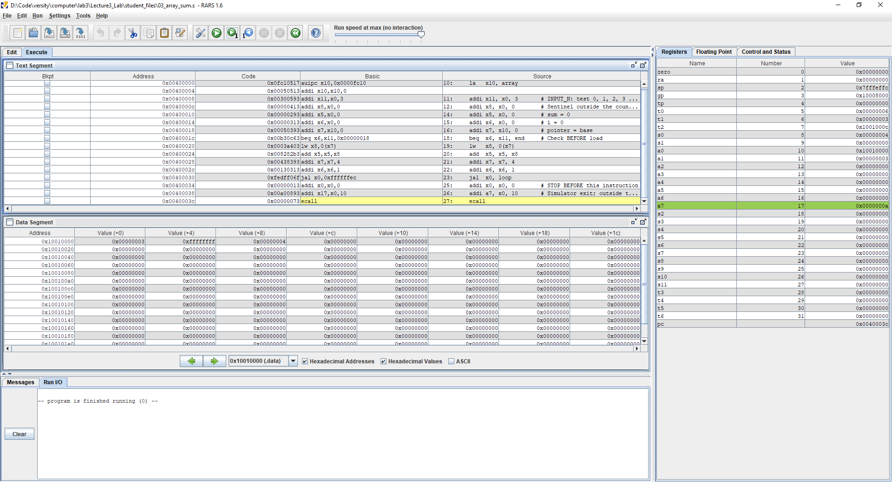
Figure C: RARS simulation for 03_array_sum.s with n=3 showing sum=6 in t0, index=3 in t1, and final pointer B+12 (0x1001000C) in t2.

Task D Find the first incorrect state
Time 20 minutes | Work on three separate copies of 03_array_sum.s
Introduce only one mutation at a time. Predict the earliest failure, run the indicated test, and repair the code. Reassemble between tests. Explain the first incorrect state or access rather than reporting only a wrong final sum.

D1 Advance by the wrong unit
addi x7, x7, 1 # replace the original +4

Use the original array with n=3. Step through the first pointer update and the next load. Record the new address and the simulator’s response. Explain why a 32-bit word array needs a four-byte stride.

D2 Read before checking the length
Move the existing lw above beq, removing it from its original position. The start of the loop now reads:
loop:
lw x8, 0(x7)
beq x6, x11, end
add x5, x5, x8

Set n=0 and keep x8 initialized to zero in the wrapper. Observe x8 at end. The final sum can still be zero: explain why that alone does not establish correctness. An allocated array is present, so an unwanted read need not trigger an address error.

D3 Stop updating the index
Delete addi x6, x6, 1 and use n=3. Single-step only two loop iterations, then stop. Compare x6 with x7. Do not run this mutation indefinitely; it eventually reads beyond the intended array.
Bug | First incorrect state or access | Repair and retest result
D1 | In the second iteration, x7 = B+1 instead of B+4. Subsequent loads will attempt to load a 32-bit value from an address that is not word aligned (B+1). | Revert back to addi x7,x7,4. The value for n=3 is loads in B, B+4, B+8. The result is 6.
D2 | When n=0, the first iteration of the loop will fetch the first value (x8 gets the value 3) before the branch on equality. This is an unnecessary fetch even though x5 is still 0 | Move beq before lw. Rerun n=0: Branch taken without loading from memory; x8 remains equal to the sentinel value of 0.
D3 | Following the first iteration, x6 continues to remain 0 although x7 is now B+4; this marks the first point of error. Following two iterations, x7 equals B+8, x6 is still 0 and x5 equals 2. This eventually results in reading past three elements. | Repair addi x6,x6,1. Repeat for n=3: index becomes 3, sum becomes 6, and the last pointer is B+12.

D4 Which test would you choose first when checking whether a loop reads too early?
Begin by picking n=0 and examining the load watchpoint/effective address or the destination register for the load operation. The fixed code now branches without the load, leaving the x8 sentinel value intact; the read-before-check transformation has caused x8 to be set to the value of the first element in the array.
Checkpoint: restore the original program and demonstrate that n=0 and n=3 both pass. Keep one clear trace or screenshot of a fault and its repaired run.

Task E Make a callable sum function
Time 15 minutes | File 04_sum_function_starter.s | Lecture slides 83–90
The caller passes a0=base and a1=n, then executes jal ra, sum_array. Your function returns the sum in a0. The supplied placeholder always returns zero; replace it with a working loop.
Value | Register | Requirement
Input base and length | a0 and a1 | Use valid nonnegative n
Running sum and index | t0 and t1 | Initialize both to zero
Pointer and loaded value | t2 and t3 | Check before every load
Return value | a0 | Copy the final sum here
Caller values | s0=123 and s1=456 | Preserve both
Return and stack state | ra and sp | Return to after_call; preserve sp

sum_array:
addi t0, x0, 0 # sum = 0
addi t1, x0, 0 # i = 0
addi t2, a0, 0 # pointer = base
sum_loop:
beq t1, a1, sum_done
lw t3, 0(t2)
add t0, t0, t3
addi t2, t2, 4
addi t1, t1, 1
jal x0, sum_loop
sum_done:
addi a0, t0, 0
jalr x0, 0(ra)

- Copy the loop structure from Task C. Use the register mapping above, with t3 instead of x8 for the loaded word.
- At the exit, copy the sum to a0 and return using jalr x0, 0(ra). This function calls no helper functions.
- Run n=0, 1, 2 and 3. Break at after_call before its nop, and record a0, s0, s1 and sp.
- Observe ra at function entry. Verify that it points to the instruction after jal, and explain how jalr uses it.

n | Returned a0 | a0 (8-digit hex) | s0 | s1 | sp
0 | 0 | 0x00000000 | 123 | 456 | equal to sp before call
1 | 3 | 0x00000003 | 123 | 456 | equal to sp before call
2 | 2 | 0x00000002 | 123 | 456 | equal to sp before call
3 | 6 | 0x00000006 | 123 | 456 | equal to sp before call

E1 Why can this leaf function avoid a stack frame?
Here’s an example of a leaf function which does not call any functions recursively within its body, and hence does not need to preserve the ra register. It maintains its context in the caller-saved registers t0-t3, without using any stack space at all.
E2 Why is replacing t3 with x8 unsafe if the function does not save and restore x8?
x8 is s0, which is a callee-saved register. The caller used s0 = 123 and therefore expects s0 to be the same. Use of x8 without save/restore will violate the calling convention since t3 is caller-saved.
Preservation test: s0=123, s1=456, and sp after the procedure equals sp before the procedure. The wrapper procedure makes sure sp is aligned before making a call, and this procedure does not alter sp at all.
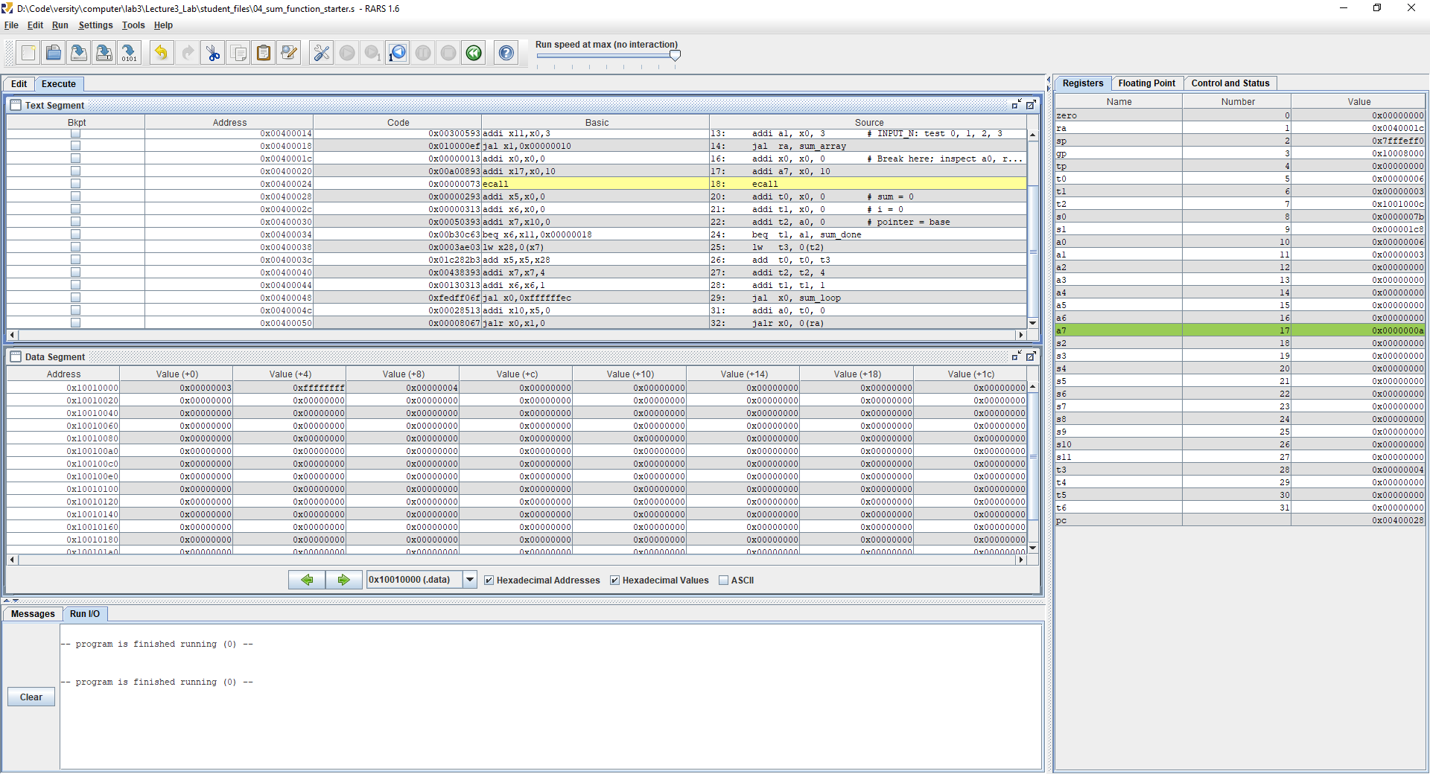
Figure E: Callable sum function in 04_sum_function_starter.s showing return a0=6, preserved s0=123, s1=456, and preserved sp.

The wrapper aligns the simulator’s startup sp to 16 bytes before calling. Compare sp immediately before and after the call, after this setup step. The function itself should not alter sp.

Optional extension after the session
Write outer(a0) = double_value(a0) + 1 using a nested call. Save the incoming ra in a 16-byte stack frame, restore it, and return. With a0=7, check the result and verify that sp is restored. This extension is not required for the 120-minute session.

Submission and exit ticket
Submit one report using report_template.md and your completed 04_sum_function.s. Include predictions, observed results, and explanations. Keep the starter files unchanged and make your edits in copies. You may submit the report as PDF or Word according to the instructor’s collection method.

Submission checklist
- A: state table and PC observation; B: byte maps and extended load values.
- C: n=0,1,2,3 results, all four n=3 checkpoints, count derivation and transfer test.
- D: diagnosis and repair for each mutation, with one useful trace or screenshot.
- E: completed source, return values and preservation checks; four exit-ticket answers.

Suggested assessment
Item | Points
A Register trace and explanations | 15
B Byte layout and load interpretation | 20
C Boundary tests, checkpoints and count | 30
D Diagnosis and repair | 20
E Correct function and preserved state | 15
Total | 100

Exit ticket
- What does lw x8, 0(x7) place in x8: the address or the word stored at that address?
- The lw instruction loads the contents of memory at location x7 into x8; it does not load the location itself into x8.
- Does addi x7, x7, 4 read memory? Explain using your observed x8.
- NO. addi x7, x7, 4 alters only the pointer. The value of x8 before this will not be altered until there is another load.
- For Task C with n=2, how many real instructions execute within the stated boundary?
- With n=2, there are 16 actual instructions that lie between the specified boundaries.
- What observation supports the claim that n=0 performs no array load?
- When n=0, the beq instruction comes before lw, as x8 will still contain zero at this point and there will be no address of array load.

Reference links
Course source: Lecture 3 Instructions and Programs, integrated 96-slide edition. Slide numbers below refer to that edition.
RARS 1.6 release and download:
https://github.com/TheThirdOne/rars/releases/tag/v1.6
RARS environment call reference:
https://github.com/TheThirdOne/rars/wiki/Environment-Calls
RISC-V calling convention reference:
https://riscv-non-isa.github.io/riscv-elf-psabi-doc/

